**VibroGlove**

**An Assistive Technology Aid for Conveying Facial Expressions**

Sreekar Krishna, Shantanu Bala, Stephen McGuire, Troy McDaniel & Sethuraman Panchanathan

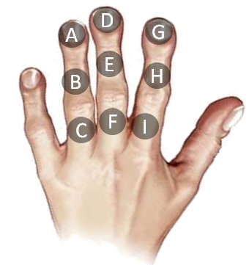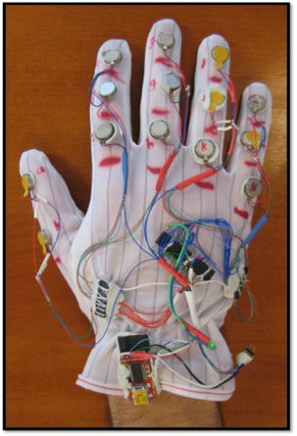**Motivation:**

* Social interactions are an essence of healthy living.
* Major portion of social interactions happen through non-verbal cues, especially visual non-verbal cues.
* People with sensory disabilities (persons who are blind or visually impaired) are at a loss due such non-verbal cues in social interactions.
* Assistive and rehabilitative social interaction aids could prove beneficial towards enriching personal and professional lives of individuals with disabilities.

**Goal:**

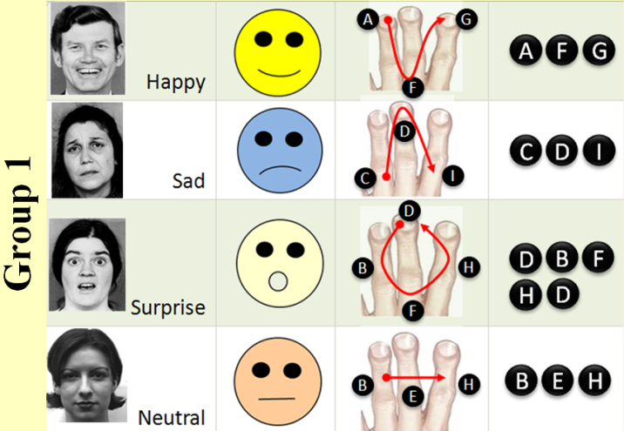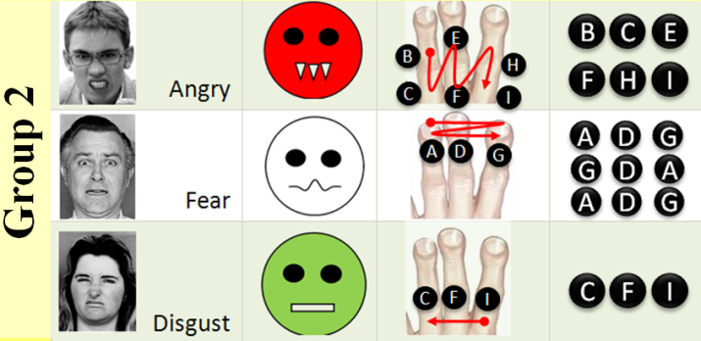Design and develop a human interaction enrichment tool that focuses on delivering facial actions of interaction partners to users who are visually impaired

**Approach:**

Vibrotactile motors on the back of a glove deliver haptic patterns that are representative of particular facial expressions. Existing computer vision techniques can be used for extracting the facial expressions of interaction partners, which are then delivered to the user’s hand in the form of haptic cues. In its nascent stage, the VibroGlove can deliver six basic human facial expressions in the form of spatio-temporal vibratory patterns.

**Future Work:**

While the six basic expressions form the basis of human emotional system, everyday facial non-verbal cues constitute complex facial muscle movements, such as, eye-brow raise, squinting of eye-lids, etc. If independent access to all facial mannerisms of their interaction partners is the goal of the VibroGlove, it is essential that subtle facial information be delivered o*ptimally* to the users in *real-time*. To this end, research is in progress to develop translations between important facial action units and distinct spatio-temporal haptic patterns so that the device offers a sensory substitution to the users for interpreting visual non-verbal cues during social interactions.



http://cubic.asu.edu

**Contact:**

Sreekar Krishna

Center for Cognitive Ubiquitous Computing (CUbiC)

Arizona State University

699 S. Mill Ave Room 380 Tempe AZ 85281

**Email:** Sreekar.Krishna@asu.edu

**Ph:** (480) 727-3612

**Fax:** (480) 965-1885